Name: Garima Neupane
Roll Number: csit2081045
Lab Number: 7

Working Expression:
t = 𝐦𝐞𝐚𝐧 𝐨𝐟 𝐟𝐢𝐫𝐬𝐭 𝐬𝐚𝐦𝐩𝐥𝐞 – 𝐦𝐞𝐚𝐧 𝐨𝐟 𝐬𝐞𝐜𝐨𝐧𝐝 𝐬𝐚𝐦𝐩𝐥𝐞
𝐬𝐭𝐚𝐧𝐝𝐚𝐫𝐝 𝐞𝐫𝐫𝐨𝐫

Working Procedure:
Define variables in variable view → put value manure 1 and manure 2 (string) → go to analyze → compare means → independent sample t –test → put values of manure in test variables and manure in grouping variable → go to options give level of confidence 95% → continue → ok

SPSS OUTPUT:
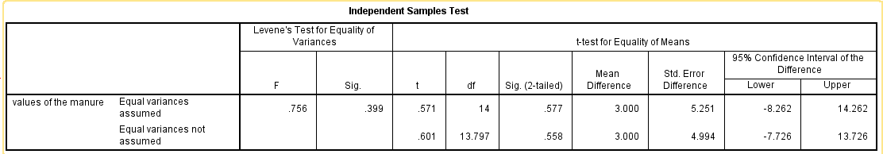

Setting of Hypothesis:
Ho: There is no significant difference between the mean yields
H1: There is no significant difference between the mean yields (two tailed test)

For Levene’s test for equality of variances, p- value = 0.389 > α = 0.05, we accept Ho Hence, equal variances assumed

Decision:
Since 2p = 0.577 > α = 0.05, we accept Ho

Conclusion:
We conclude that there is no significant difference between the mean yields.

